Interfacing DAC with 8051


LAB # 12

Spring 2024
CSE-307L Microprocessor Based System Design Lab

Submitted by: Ali Asghar
Registration No.: 21PWCSE2059
Class Section: C

“On my honor, as student of University of Engineering and Technology, I have neither given nor received unauthorized assistance on this academic work.”

Submitted to:
Dr. Asif Ali Khan

Date:
1st June 2024

Department of Computer Systems Engineering
University of Engineering and Technology, Peshawar

Task 1:
Generate the following waveform
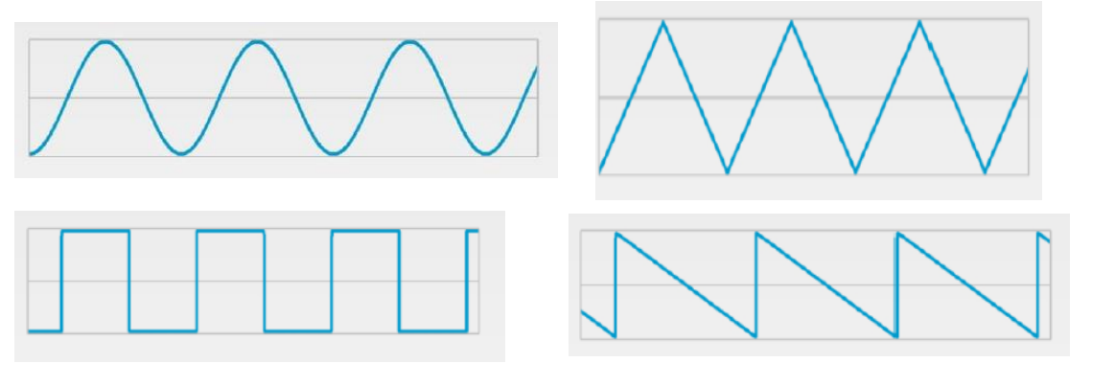
You can use a button, when pressed once then generate triangular wave, when pressed again generate the square wave and so on. Use Port-interrupt for button detection.

Code:
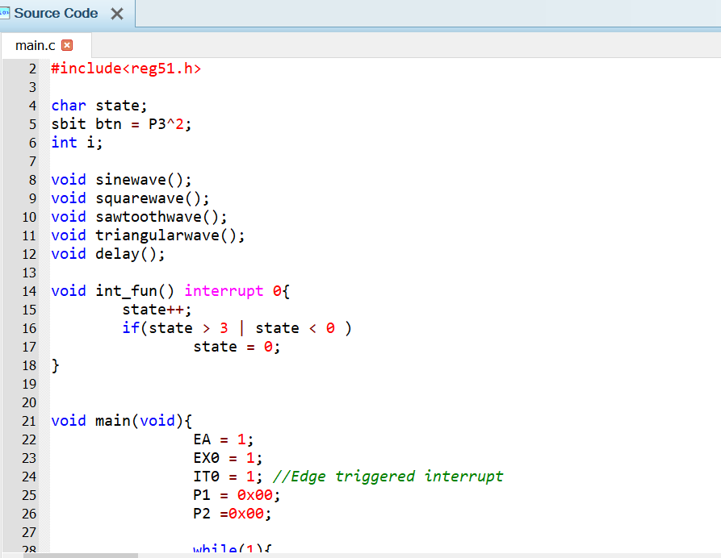
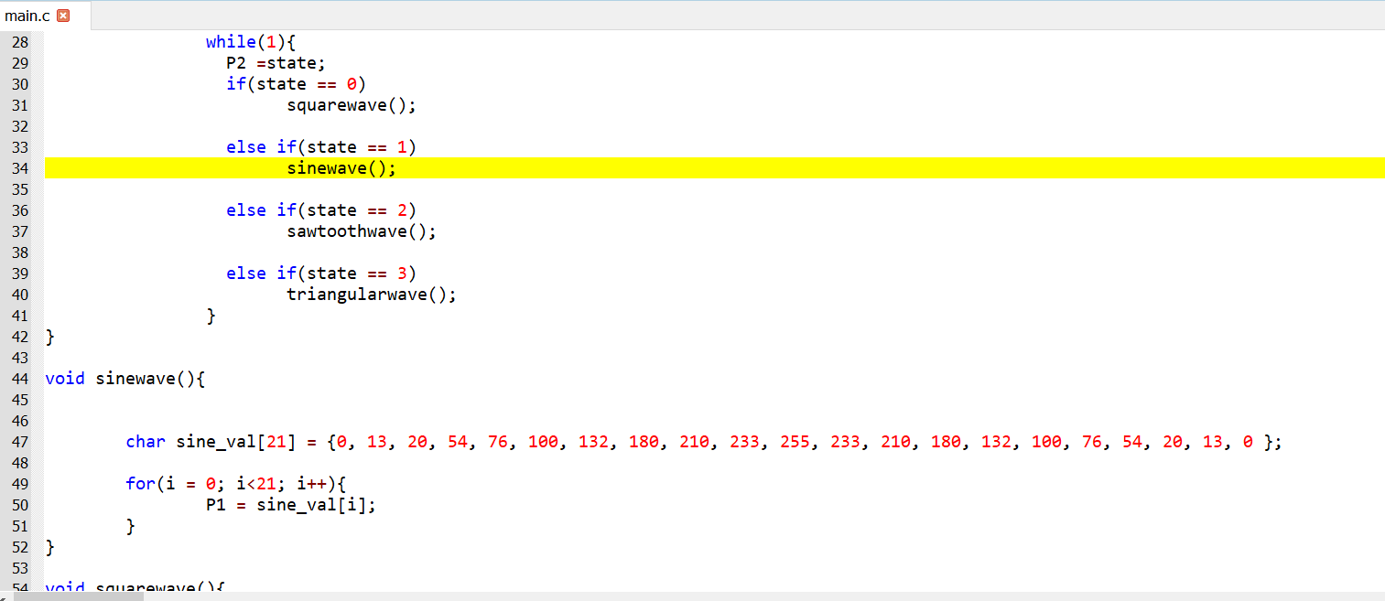
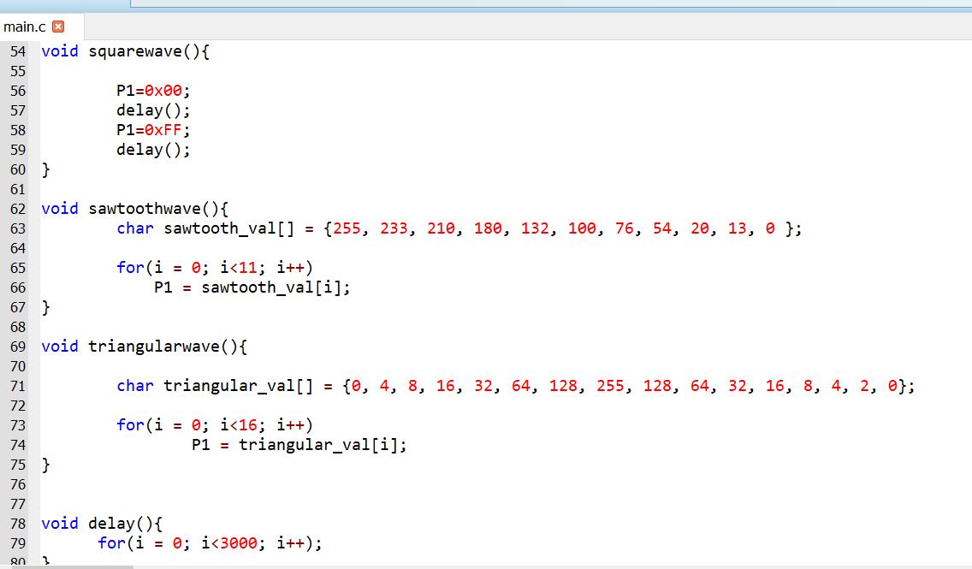

Proteus Simulation:
